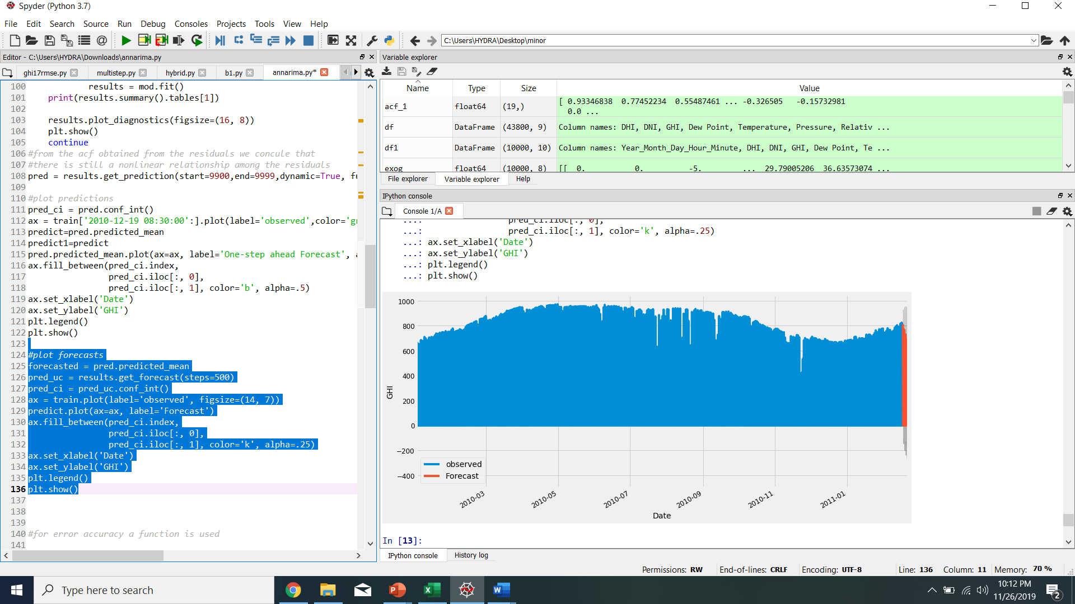

Fig 1: Barmer SARIMAX GHI forecasted

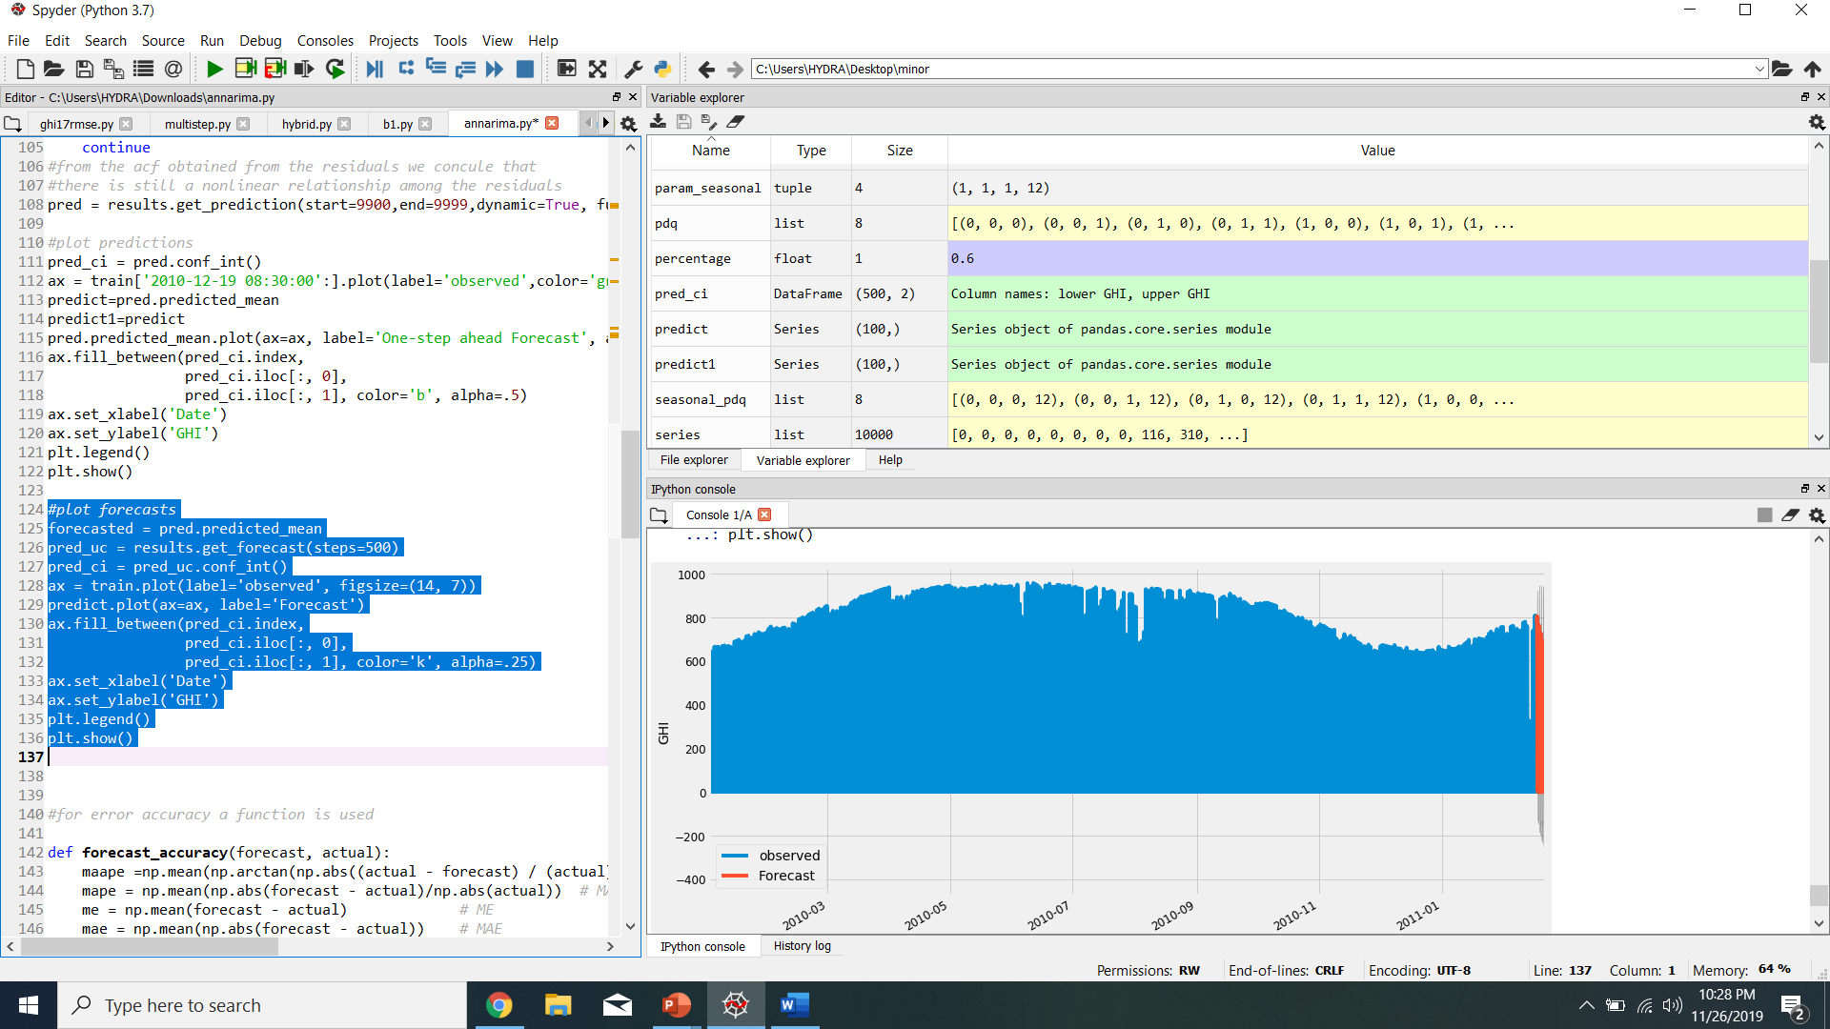

Fig 2: Bikaner SARIMAX forecasted

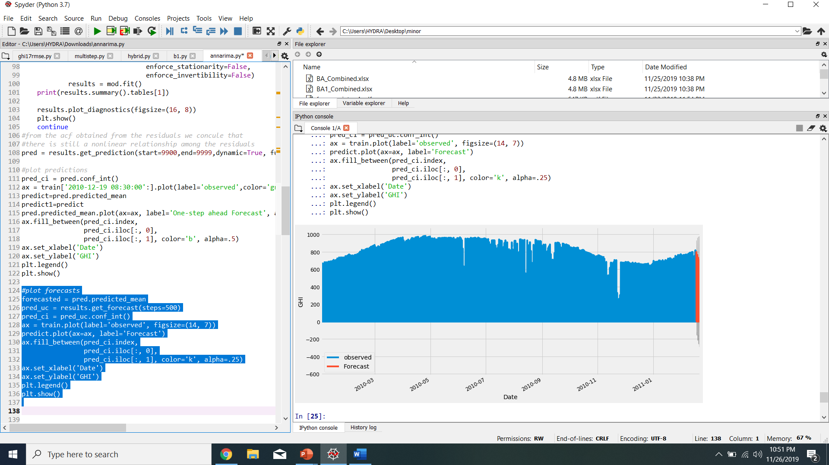

Fig 3: Jodhpur SARIMAX GHI FORECASTED

JAISELMER

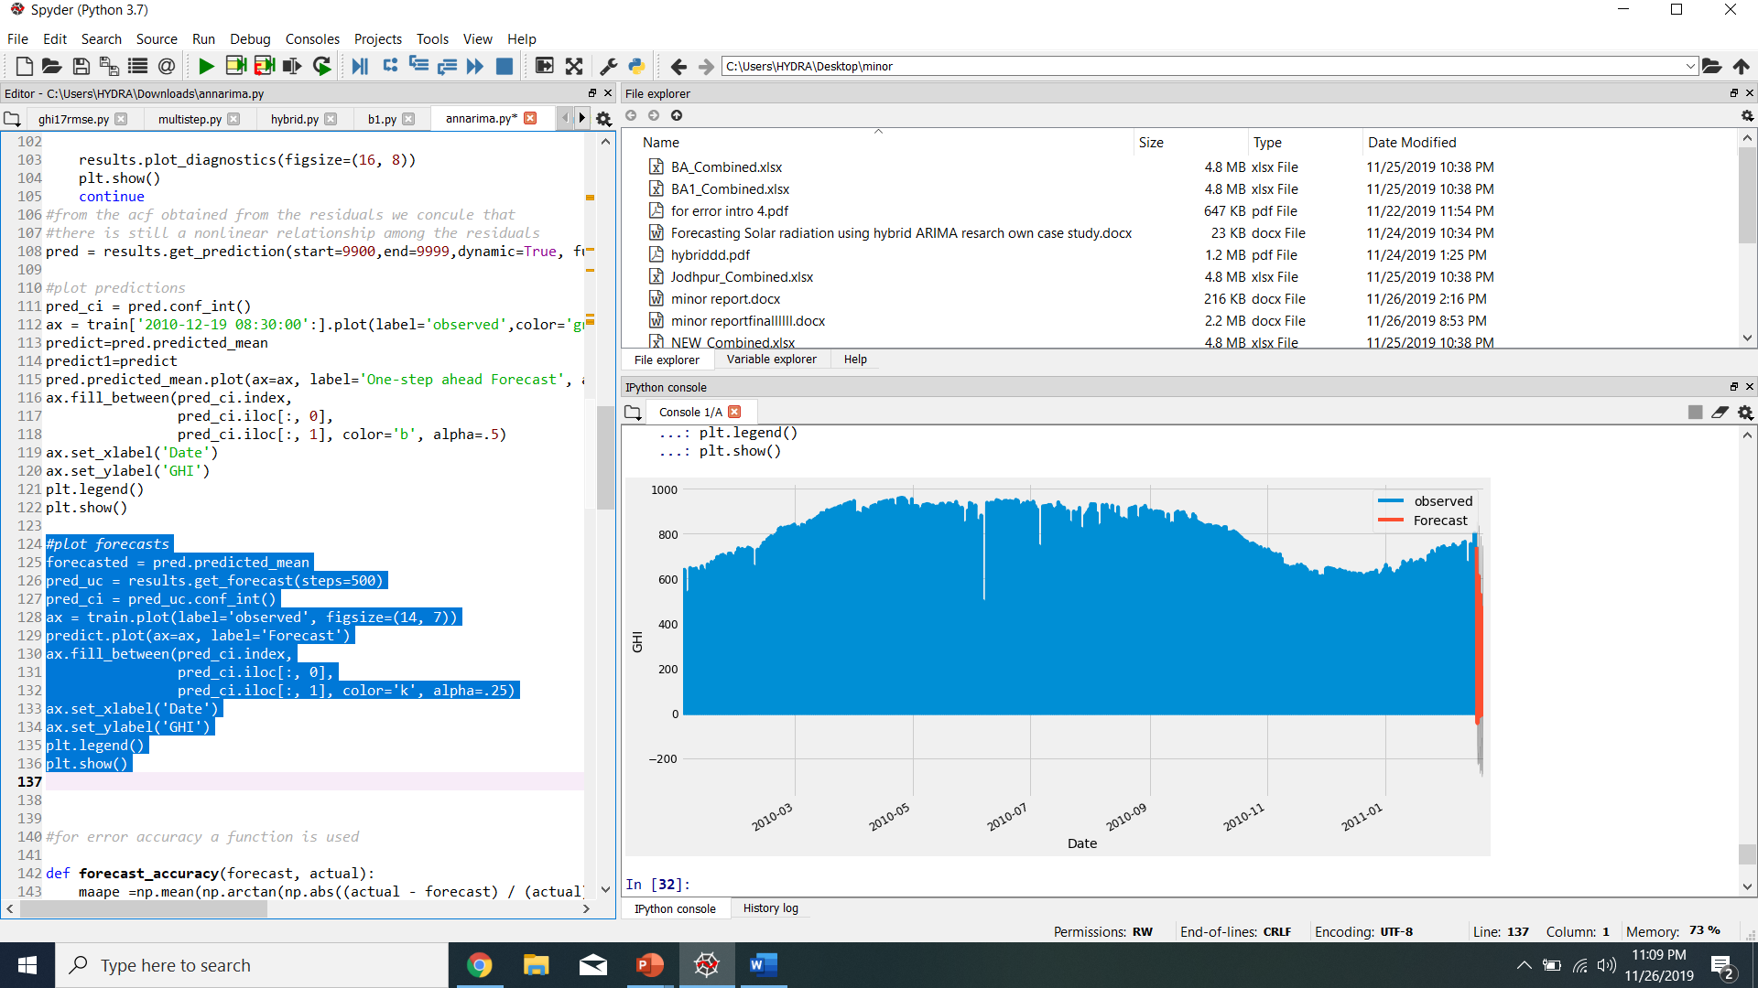

Fig : Jaiselmer SARIMAX GHI FORECASTED

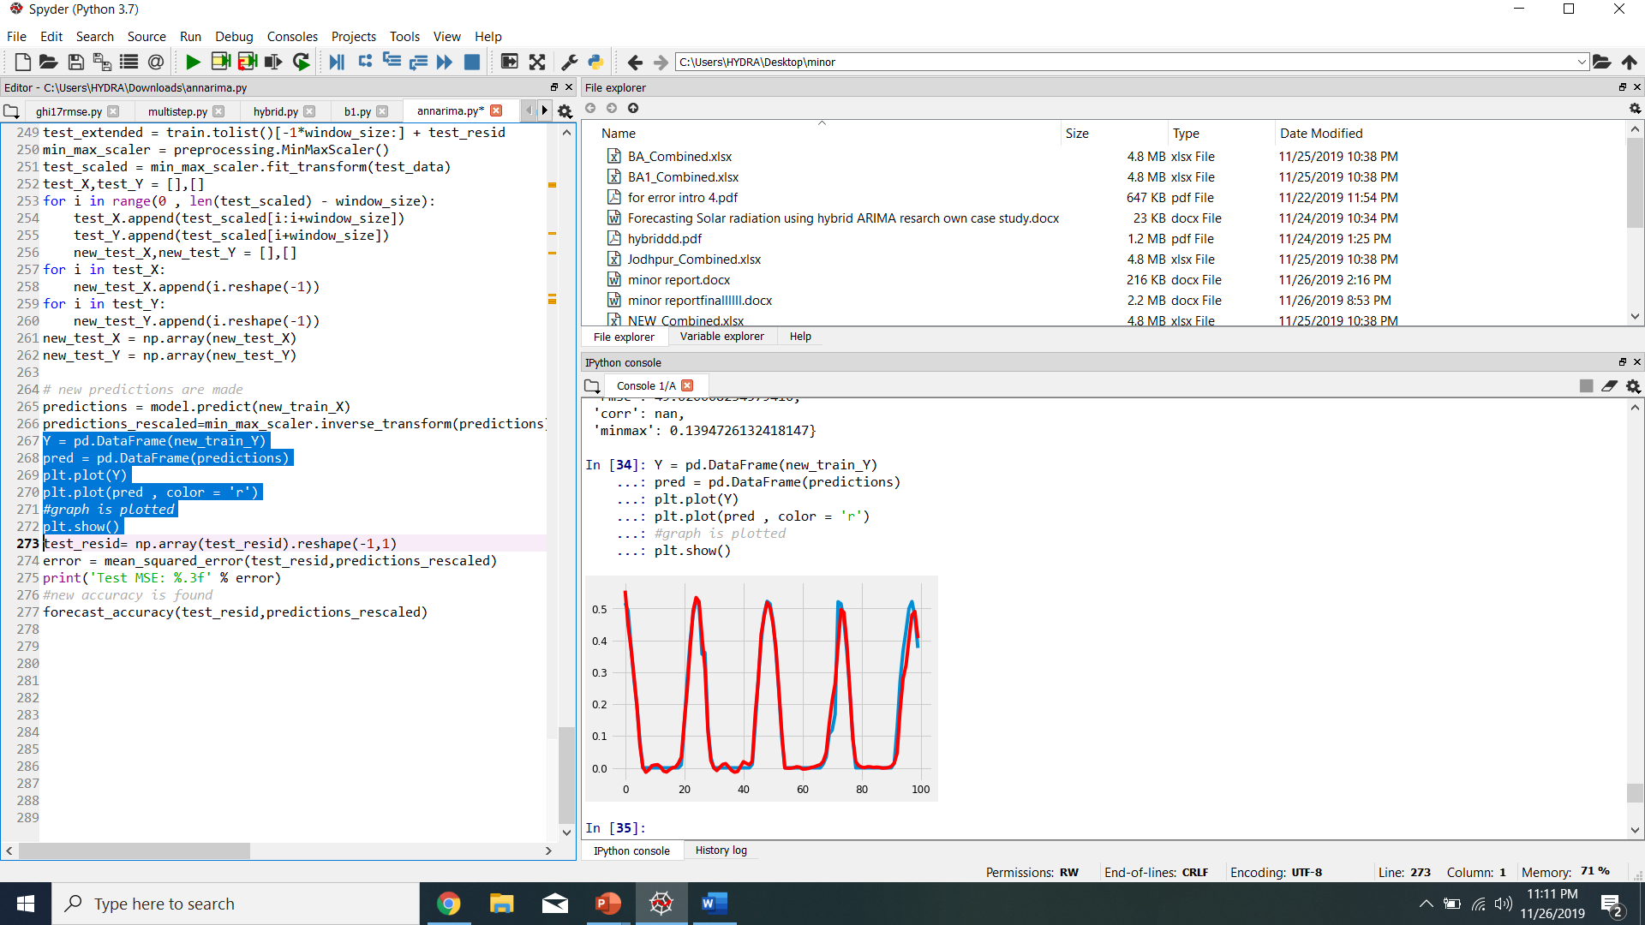

Fig 5: JAISELMER HYBRID(TEST RESIDUAL – PREDICTIONS RESCALED)

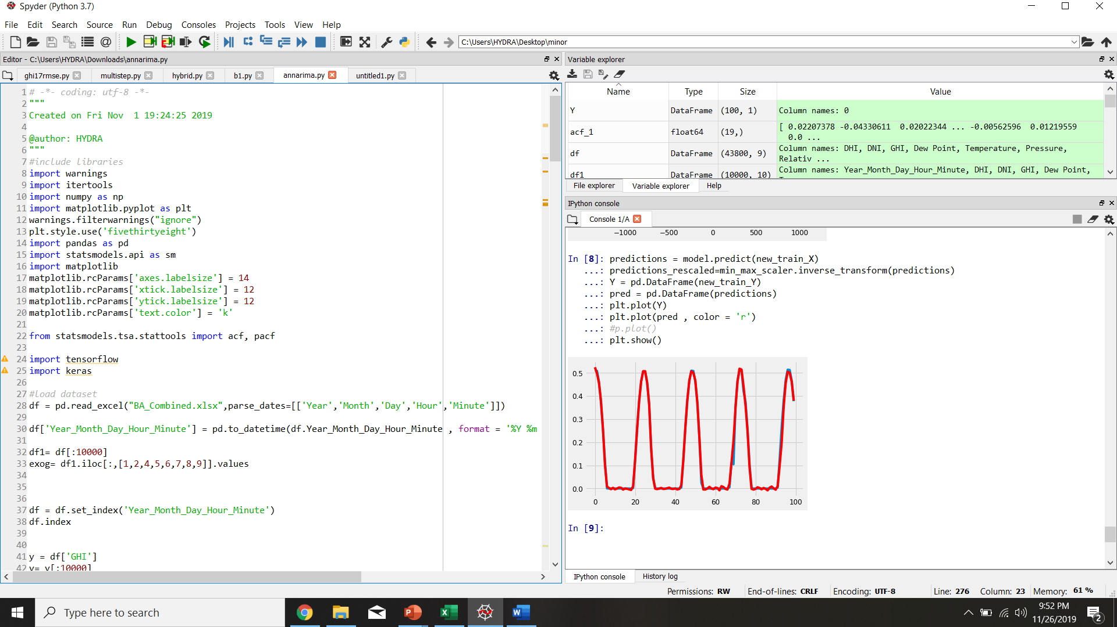Fig6:Barmer hybrid (test residuals and predictions rescaled)

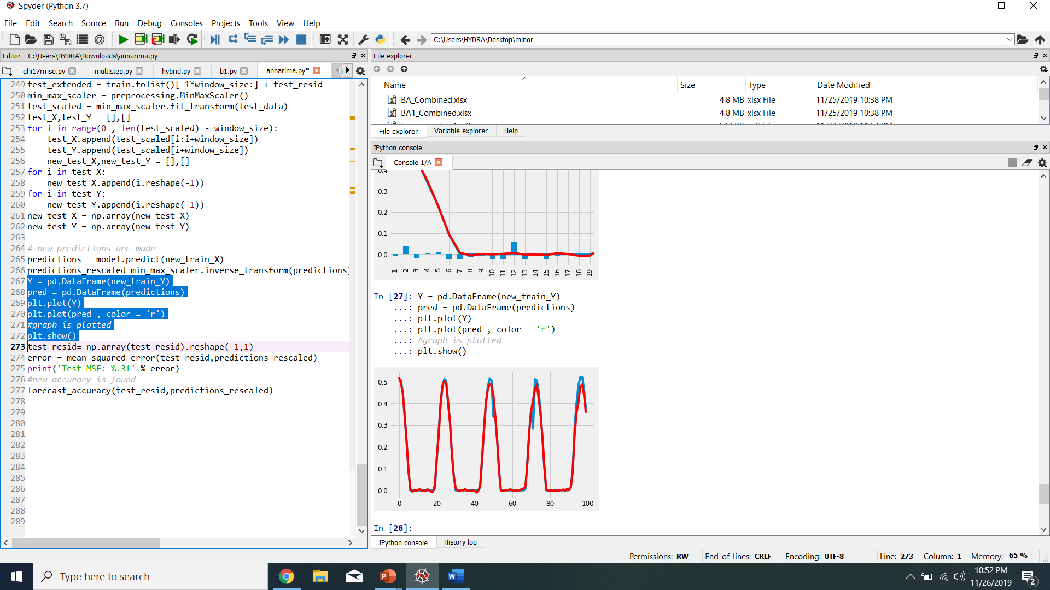

Fig 7: JODHPUR HYBRID (TEST RESIDUALS AND PREDICTIONS RESCALED)

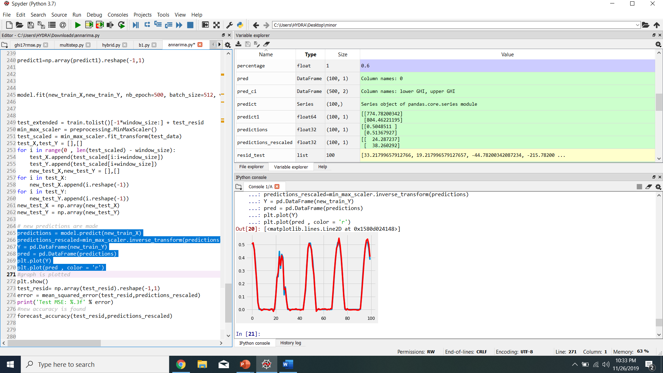

Fig 8: Bikaner hybrid (test residuals and predictions rescaled)